**Project Team: Safaa, Maya, Christa, and Kevin**

**Github Link:** <https://github.com/mhdennis/project2>

**Project Theme**: *Olympics – Media coverage, viewership, and sentiment analysis*

**Potential Data Sources:**

* Olympics data online
  + <https://www.theguardian.com/sport/datablog/2012/jun/25/olympic-medal-winner-list-data>
  + https://sportradar.us/2017/12/2018-winter-olympics-api/
* Instagram API <https://www.instagram.com/developer/>
* News coverage
  + <https://www.nytimes.com/>
  + <https://www.theguardian.com/us>
  + <https://www.washingtonpost.com/graphics/2018/sports/pyeongchang-2018-olympic-medal-count/?utm_term=.ffb7d38e094e>
* Viewership <https://www.statista.com/statistics/287966/olympic-games-tv-viewership-worldwide/>
* World Bank data for GDP <https://data.worldbank.org/indicator/NY.GDP.MKTP.PP.KD?end=2016&start=2010>

Note: Due to the diversity of data sources, we expect that some data management steps would be needed in order to standardize

**Research topic and rational:**

Analysis of the Olympics data from different perspectives to assess the results, media coverage, viewership, and sentiment. Our goal is to create a website with the results of the analysis including maps, gifs, data, and graphical displays.

Some of the research questions might cover the following:

* Which countries do well in summer compared to winter Olympics
* Gender analysis
* Comparing the results of the Olympics across years for the past 10 years
* Explore correlation between country GDP and number of Olympic Wins
* Drop in viewership for Olympics
* Web scraping of news coverage for Olympics

**Some example screenshots of data, visualization, and gif**

1. Mix of Bar charts and Maps

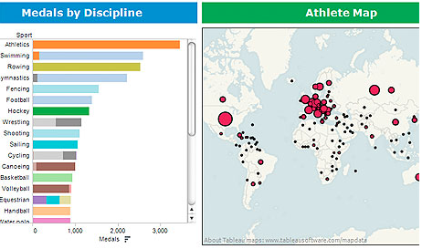

1. GIF - Instagram

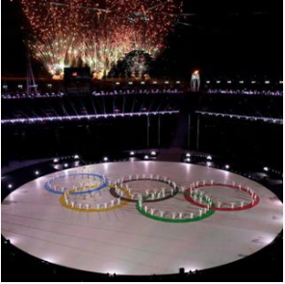

1. Interactive Map of Olympic Medals in Bubble + Geographic Form

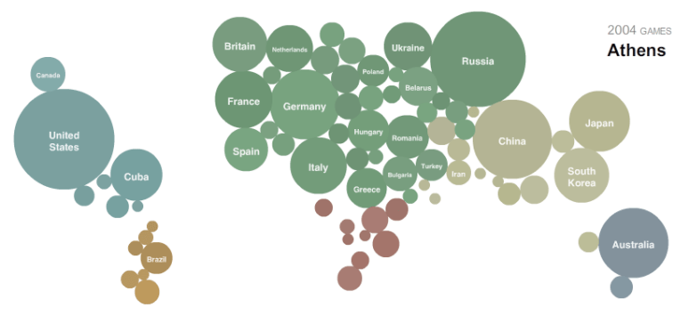

1. Data Tables

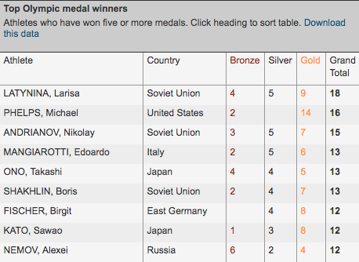

1. Streamgraph of Olympic winners

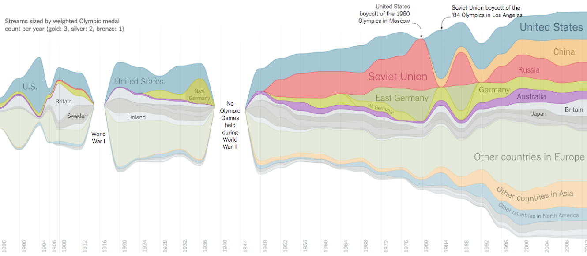

**End Result Webpage**

* A website with at least 5 pages
* The landing page will have a link for different pages and summaries
* Dashboard will have statistical summaries
* Interactive maps
* Drop down links
* API for the data
* Pages on methodology and references

***Example screenshot of landing page (see below)***

